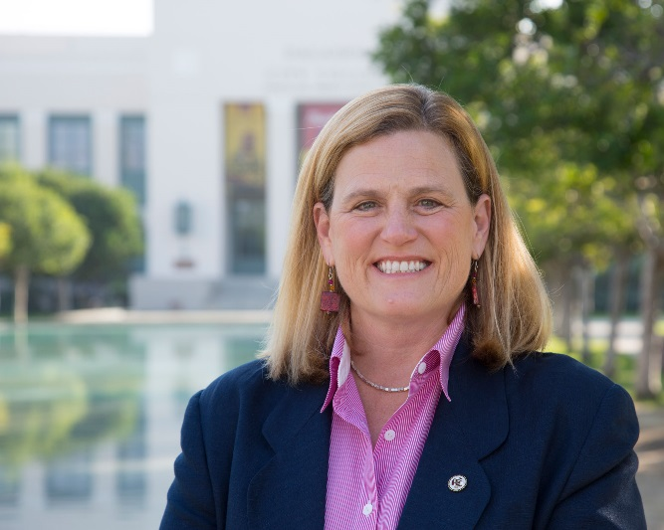In this activity we will try to guess an unknown number. We will explore how the range of our guess affects how confident we are that we are correct.

This is the ______________________ of Pasadena City College. In your groups you are going to use critical thinking to guess her

__________________.

Your group’s guess: ________________

**1.** Give the interval age ranges for your guess (subtracting and adding the time from your guess above):

Within 25 years of your guess would be between _____________ and _____________ years old.

Within 10 years of your guess would be between _____________ and _____________ years old.

Within 5 years of your guess would be between _____________ and _____________ years old.

Within 1 year of your guess would be between _____________ and _____________ years old.

Within 3 months of your guess would be between ________________ and _____________ years old.

**2.** Fill in the following table.

|  |  |  |  |  |  |
| --- | --- | --- | --- | --- | --- |
| How confident is your group that your guess is correct to within… | | | | | |
| (*put check mark*) | Certain | Likely | Somewhat Likely | Unlikely | No Way! |
| 25 years of her actual age |  |  |  |  |  |
| 10 years of her actual age |  |  |  |  |  |
| 5 years of her actual age |  |  |  |  |  |
| 1 year of her actual age |  |  |  |  |  |
| 3 months of her actual age |  |  |  |  |  |

**3.** Have one person from your group put your tally marks up on the board.

**4a.** What pattern do you see in the tally marks on the board?

**4b.** Notice that the ____________________ the interval the more confident you are that you are correct.

Conversely, note that the ____________________ the interval the less confident you are that you are correct.